**UNIT 2 Solution**

1. Conduct a one tailed test of significance (hypothesis test with α = .01) to test the claim that the intrinsic group has a higher mean creativity score than the extrinsic group. Be sure and show all 6 steps. Use SAS (Elliot and Woodward page 189 and the sample code in the SAS folder on Blackboard) to produce your statistics and conduct your test but don’t simply turn in computer output. Write it in the form of the six steps we covered in class and pay close attention to step 6: Writing the conclusion of the test in non-statistical / easy to understand terms. Do you need to divide the p-value in half? Why or why not?

Step 1: Ho: µi - µe ≤ 0 Ha: µi - µe > 0

Step 2: df = 45 Critical Value = 2.412

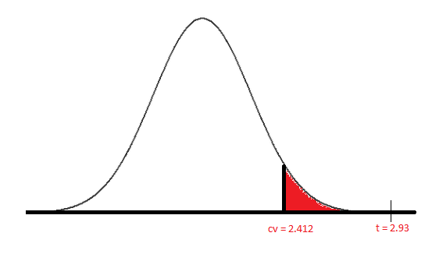

Step 3: t-statistic = (4.14 – 0)/(4.85*sqrt(1/24 + 1/23)) = 2.93

Step 4: p-value = 0.0027

Step 5: Reject the Null Hypothesis

Step 6: There is compelling evidence at the alpha = .01 level of significance (pvalue = .0027) to suggest that the intrinsic motivation causes an increase in the mean creativity score with respect to those in the extrinsic group.

1. Construct the appropriate confidence interval (correct confidence level) for the test in question 1 and report the plausible values of the difference in mean creativity score between the intrinsic and extrinsic groups. Is it consistent with the test conducted in question 1.

We are 98% confident the true difference of the means between the intrinsic group and the extrinsic group is in the interval (7.3, 7.6). Note that this is a one sided test therefore the “appropriate” two sided test to compare it to (for alpha = .01) is a 98% confidence interval. This is because we must balance the .01 on each side in order to provide for a two sided confidence interval. There are also one sided confidence intervals but for now we will only consider the two sided interval. (If this were a two sided interval, the alpha would have already been split into the two tails and thus we would have compared it to a 99% interval.

1. What assumptions were made in question 1 so that we could use the 2 sample t test? Use histograms and possibly other statistical tools to check these assumptions.
2. We need both samples to come from populations that are normally distributed. This can be checked with a histogram and QQ plot.

|  |  |
| --- | --- |
|  |  |

The histograms are absent of any extreme outliers and since the sample size is only 24, this certainly looks like data that *could* have been randomly selected from a normal distribution. The QQ also do not provide evidence against a normal distribution. There are only minor departure from the line**. Note here that we are not saying that the histograms and QQ plots indicate the data come from a normal distribution, only that they do not provide sufficient evidence that they do not come from a normal distribution.**

1. We also need both samples of data to be drawn from populations with the same standard deviation. The best check of this, as with the check of the normal distribution, is a visual inspection. Again, there are no extreme values and the histograms and boxplots look to be consistent with the data coming from populations with equal standard deviations. Soon we will discover hypothesis tests in which will help us gather evidence to test this assumption. The hypothesis will be:

Ho: The data come from populations with equal standard deviations.

Ha: The data do not come from populations with equal standard deviations.

Ask about these tests in Live Session!!!

1. A final assumption is that of independence. The problem states that the subjects were volunteers thus we cannot be sure that the subjects are independent. If they were to be from the same family or studied at the same school or came from the same class we may have reasons to believe that the subjects are not independent. However, in cases like this, where the we do not have enough information we should simply state the uncertainty and “proceed with caution.”